**Senior Product Manager, Public Protection**

**Product Management, Idox Software – Local Government**

**Home Based, UK**

# About the role

This is a new post created to enhance our Land, Property and Public Protection Product Management team, which manages Idox’s Built Environment and Public Protection products designed for Local Government.

Reporting to the Head of Product and Strategy, the Senior Product Manager will play a key role as the owner, senior stakeholder, and gatekeeper of all matters relating to the company’s Public Protection portfolio of products to ensure Idox delivers a high quality, relevant and market leading offer.

The scope of product responsibility will include, but is not limited to, products relating to Environmental Health, Licensing, Trading Standards, and Housing, and supporting technologies such as online digital channels and mobile apps. These largely involve the Uniform and Idox Cloud brands.

As the Senior Product Manager, you will be responsible for a team of product owners and/or specialists covering key responsibilities including pre-sales, product analysis, requirements gathering and other activities relevant to the Public Protection domain.

There will also be a requirement to help inform the company’s strategy by acting as an evangelist of the company’s products. This includes being a voice on social media, engaging in relevant network opportunities and looking to the horizon to inform future product strategies which support the company’s growth aspirations.

Idox is a market leader in these areas so this is an excellent opportunity for a domain expert to elevate their career and make a huge impact on the Public Protection market. The key to success will be strong organisational skills and an ability to network and engage heavily with internal and external stakeholders with a primary focus on customer outcomes.

We have a talented product team where we expect a culture of pride and excellence in the products and services we offer to our customers, this is the minimum our position as market leader demands.

# Key Responsibilities

* To be Idox’s and therefore the market voice on all matters relating to Public Protection
* Ownership of the overall public protection product strategy
* Ownership of the Public Protection roadmap
* Effective management of a pre-determined engineering budget
* Continuous improvement of the customer experience by ensuring the product has a user centred design and is easily administered and implemented by professional services colleagues
* A focus on ensuring Idox products drive more efficient back-office processes in local government but at the same time remain legislatively compliant
* A detailed focus on functional and non-functional requirements of enterprise software products ensuring a consistent and high-quality process for requirements capture is followed
* The development of a documented “golden build” deployment for each major product area which represents an industry standard for Public Protection case management systems
* Multi-stakeholder management (customers and other external stakeholders, service desk, engineering, sales, delivery, marketing)
* Customer product engagement plans, strategy and product demonstration
* Line management of the Public Protection product team to ensure a high performing product team
* Ensure teams adopt Idox product management and engineering standards (Agile) by using Idox’s product management information systems
* Regularly report on product roadmap, project progress and discrete product projects.

# To be successful, you’ll need to bring:

* A good sense of humour and an ability to think “outside the box”
* Management experience managing direct and virtual teams
* 5+ years of experience within the Local Government Public Protection domain as a product owner and/or Local Government practitioner
* Knowledge and experience of Agile software product management processes with a communicable understanding of this role's responsibilities within an Agile SDLC
* The confidence to present product ideas and roadmaps to internal and external audiences
* The confidence to engage with customers and other external stakeholders directly or at events
* An ability to demonstrate software products to internal and external stakeholders
* A deep knowledge and understanding of the public sector
* An analytical mind with an attention to detail
* A strong and organised administrator
* Ability to develop trusted relationships with colleagues
* Adaptive style to managing different internal stakeholders
* A high level of commitment and passion for achieving outstanding levels of success and service excellence
* Has a results-driven focus with good business and commercial judgement
* Excellent communication skills, consultative approach and able to influence others to support objectives
* Excellent time management and prioritisation skills
* A clean driving licence and access to a car
* An ability to travel to different Idox office locations when necessary.

# About Idox

Our specialist software solutions power the performance of government and industry, driving productivity and a better experience for everyone. Built around the user and designed in collaboration with experts who have worked through every detail of every process from end-to-end, our hard-working process engines deliver exceptional functionality and embed workflows that drive efficiency and best practice with a long-term focus for regulated environments.

Through the automation of tasks, the simplification of complex operations, finding scalability as operations evolve, and more effective management of information, we help our customers harness the power of Digital, so they can do more.

We employ around 660 staff in the UK and worldwide, including Europe, North America and Asia, so some travel to meet colleagues may be required.

Our Values 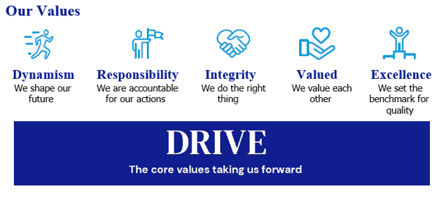

# Our Culture

We are ambitious in working together to promote a more inclusive environment, which attracts all candidates and signals our commitment to celebrate and promote diversity. Idox is a company where we can all be ourselves and succeed on merit, where we respect all our employees, customers and communities in which we live, work and are a part of.

We recruit and reward employees based on capability and performance – regardless of race, gender, sexual orientation, gender identity or expression, lifestyle, age, educational background, national origin, religion or physical ability. Each office location worldwide, is free to respond to local needs to create a culturally sensitive workplace for everyone. In doing so, we want every employee to feel our commitment to showing respect for all and encouraging open collaboration and communication.

# Our Benefits Flex to Fit

We recognise that for individuals, the opportunity to work flexibly can enable them to achieve a better work-life balance along with a greater sense of responsibility, ownership and control of their working life. During the pandemic, all our employees successfully transitioned to remote working and we are open to conversations on work patterns to suit our employees needs such as change to working times; part time working; term time working; 9-day fortnight. We are proud to be a flexible employer enabling effective hybrid working for our employees.

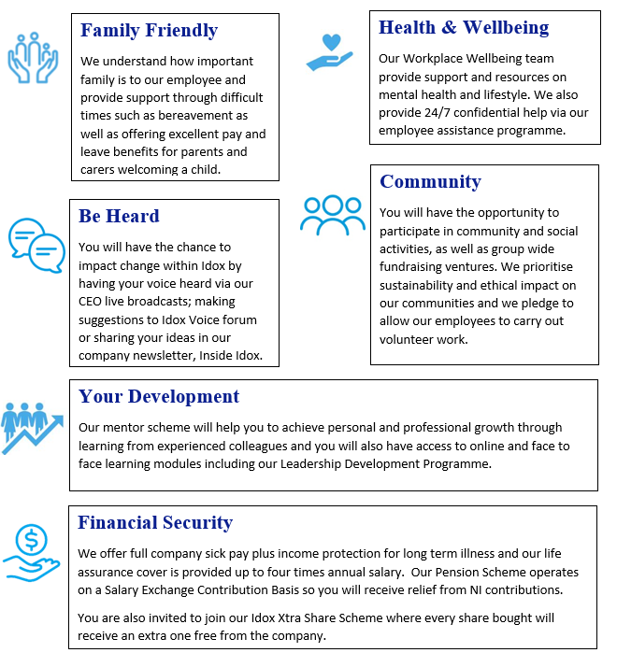

# How to apply

**Please submit a CV, and a short cover letter *(maximum 500 words - including salary expectation, and current remuneration)* explaining why you feel you would be suited to this role to join.us@idoxgroup.com**

Please note successful applicants will need to satisfy the BPSS guidelines (Baseline Personnel Security Standards) which consist of the receipt of satisfactory references covering the last 3 years of employment; an identity check; verification of eligibility to work in the UK; and a Basic Disclosure Check. This is in order to help us make safer recruitment decisions.

# Privacy notice

As part of the recruitment process, we will collect data about you in a variety of ways including the information you would normally include in a CV or a job application cover letter, or notes made by our recruiting officers during a recruitment interview. Please read our Recruitment Data Privacy Policy here: **https://www.idoxgroup.com/policies**